**Work Order No. XXXX**

**Dated __ Feb 3rd, 2021_**

**To the IT Master Services Agreement**

**Between Gilead Sciences, Inc. and __ WinWire Technologies Inc._____**

This Work Order (“**Work Order**”) effective as of _02/15/2021_ (“**Work Order Effective Date**”) sets forth the project scope, deliverables, fees and terms relating to specific Services provided by __ WinWire Technologies Inc. ____ (“**Company**”) to Gilead Sciences, Inc., (“**Gilead**”) pursuant to the Master Services Agreement (“**Agreement**”) between the parties dated ___ January 28, 2013____Amended from time to time_________. Capitalized terms used herein not defined will have the meanings given such terms in the Agreement.

**UNITY Project** (Gilead to check which applies): _X___ Yes

_____ No

1. **Project Scope:**

Following activities are identified to be part of scope for the implementation of the Enrollment & Stipend app – MVP

1. Below are the high-level requirements to be part of the MVP
   1. **Registration/de-registration of device and raise request for stipend**
      1. System should enable user to log into the system using its Gilead credentials
      2. The system shall determine if the user is an employee or contractor
      3. The user shall select the stipend tier to be considered for their request (user can request any stipend amount which is subject to manager approval, only if users are eligible for the stipend)
      4. The system shall present the user the stipend tiers based on country (USA for MVP)
      5. The system will present the terms and conditions for enrollment to the user
      6. The system will only let the user enroll if the user agrees to the terms and conditions for the stipend program
      7. The system will store the date and time the user agreed to the terms and conditions
      8. The system should allow users to request an increase/decrease in the stipend amount
      9. System shall allow employees (in some circumstances) to opt out of stipend
      10. The System shall present opt-out agreement and will track user acceptance of agreement
      11. System should link back to Device enrollment information on G.Net portal
   2. **Manager approval process**
      1. The system will send line managers an email requesting approval for enrollment
      2. The system will allow managers to login to view pending enrollment / stipend requests in the queue
      3. System will let manager approve/reject individual stipend requests (individual and bulk)
      4. If approved, the system will send users email with a link to enrollment instructions informing them they have been approved to enroll a personal device
      5. If rejected, the system will send users email informing them their request for
      6. has been denied
      7. System will display a summary of all approved stipends for a given manager
   3. **Admin functions**
      1. Stipend admins should be able to sign up employees for a custom stipend amount
      2. MVP Only: System will not need to have admin function to update stipend information (tiers, descriptions, amounts) for USA. This could be stored in a configuration file
      3. MVP Only: System will hard-code the stipend approval hierarchy as applicable: (Define up to two levels of approval and define the level that can be self-approved)
   4. **Integrations** 
      1. System shall integrate with Gilead Active Directory
      2. System shall send payroll list of users currently receiving stipend with the stipend level each month
      3. The system will update the AD group with the approved users for enrollment in the Gilead Device Management (MS Intune)
   5. **Reporting**
      1. Enable reporting capabilities which will provide insight into the enrollments into the program. MVP to include
         1. Payroll report
         2. Report for users which are accepting/rejecting the term and conditions
2. Project should follow Gilead’s Agile SDLC process
3. Conduct requirement gathering sessions with Gilead team and prepare user stories
4. Documentation as per Gilead UNITY framework specifications
5. Conduct backlog grooming sessions with Gilead team
6. Prepare user interface (UI) mockups for the system and present it to Gilead team and gather feedback & sign off
7. Prepare technical architecture and design and present it to Gilead team and gather signoff
8. Develop /test / deploy the application in Gilead’s environments
9. Coordinate and conduct Gilead user testing and present work-in-progress demos
10. System development and unit testing with periodic sprint demos to Gilead team
11. System testing and bug fixing
12. Create test plan and strategy
13. Create scenarios and test cases
14. Perform system testing and bug fixing
15. Support user acceptance testing done by Gilead team
16. System go-live and cutover from current system to new system
    1. **Out of Scope**

Following are the list of items considered out of scope for this engagement

1. Any activities not defined as part of Planned Scope & Activities section of this document
2. Migration of the data from existing Stipend app to the new system
3. Resolution of any existing functionality in the current Stipend system
4. Procurement of any hardware and software licenses
   1. **Assumptions & Dependencies**
5. Gilead will provide all necessary access to the G.Share Online (SharePoint Online ), other relevant systems, network, and documentation
6. Gilead team members to be available during their local business hours for calls to answer questions from WinWire team
7. Gilead will review all deliverables from the project team promptly and provide appropriate feedback and comments
8. Gilead to provide development environment for all development and unit testing activities
9. Gilead to provide the testing environment to perform System and UAT testing
10. Gilead team will review and sign-off the design and other required documents
11. Gilead will provide access to its current systems for analysis and access to the latest version of relevant documents
12. Procurement of third-party tools will be the responsibility of Gilead if needed

2. **Term:**  Services will begin on 02/15/2021 and will be completed in **10 calendar weeks** from the start date

3. **Tasks/Deliverables/Acceptance Criteria:**

All Deliverables are subject to review and acceptance by Gilead. Any acceptance process set forth in the Agreement shall apply. In addition to the general Acceptance Criteria below, each Deliverable is also subject to additional Acceptance Criteria specific to such Deliverable.

*General Acceptance Criteria:* The Services shall be performed in a manner consistent with generally accepted and current information technology industry standards and in accordance with Gilead’s directions and standard operating procedures. The Deliverables shall be compliant with system documentation and specifications and shall be fully integrated into Gilead’s systems such that no latency, delay, redundancy, or system degradation is experienced. The Deliverables shall perform in accordance with any specifications and requirements agreed to between the parties, in a manner that meets Gilead’s project objectives, passes Gilead user acceptance testing, and to Gilead’s reasonable satisfaction

|  |  |  |
| --- | --- | --- |
| **Week(s)** | **WinWire Team’s Activities** | **Gilead** **Team’s Tasks** |
| 1 | Sprint 0   1. Requirement gathering sprint planning sessions 2. Develop UI mockups and present it to Gilead team 3. Backlog – User stories, Sprint plan 4. MVP design activities 5. Test execution plan and test cases 6. Daily scrum calls | 1. Meeting time for key stakeholders and technical SME 2. Participate in requirements and technical design sessions 3. Meeting time to clarify WinWire team’s question 4. Review the Prototype scope and technical design 5. Review the user stories and signoff 6. Participate in daily scrum calls |
| 2-9 | Sprint 1-4   1. Prototype implementation activities 2. Drive and participate in daily scrum calls 3. Work-in-progress demos | 1. Meeting time to clarify WinWire team’s questions and demonstrations 2. Participate in daily scrum calls |
| 10 | Sprint 5   1. Rollout and cutover from old system activities 2. Power go-live support | 1. Meeting time for demonstrations 2. Support to WinWire team in system rollout activities |

**Planned Deliverables**

1. Backlog – User stories, Sprint plan
2. Requirements document
3. User Interface (UI) mockups
4. Detailed Design document
5. Test execution plan and test cases
6. Implemented system as per scope defined in above section and user training manual

5. **Project Schedule:**  The following is the proposed project execution timeline

1) The duration of the engagement is estimated to be **10 calendar weeks**

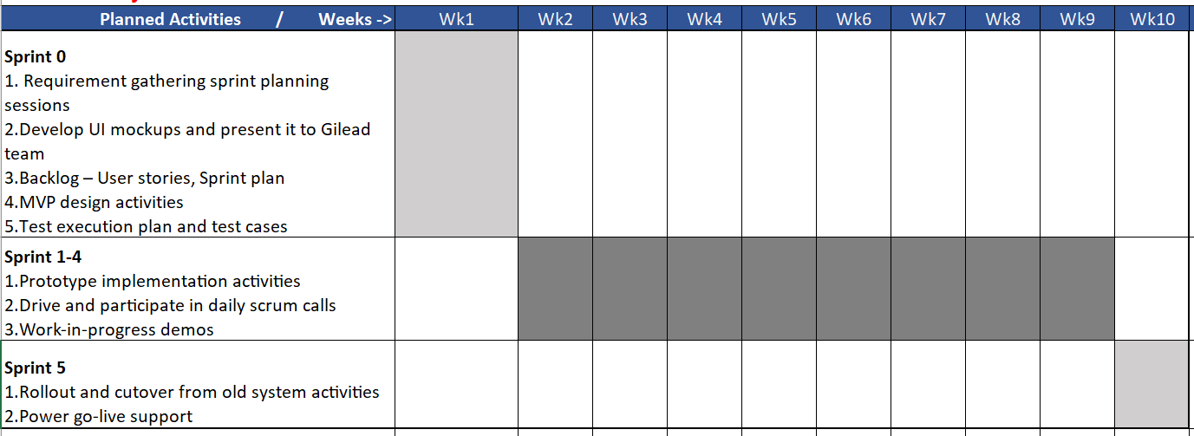

8. **Project Management:**

**Gilead Project Manager** – Gilead will provide the Project Manager as the Gilead point of contact for the Services provided by Company under this Work Order. The Project Manager will be responsible for the following:

1. Reviewing and understanding the responsibilities of each party under this Work Order and providing guidance as to Gilead’s requirements.
2. Maintaining regular communications with the Company Project Manager on matters relating to the Services and serving as the interface between the Company and Gilead’s project teams.
3. Reviewing and administering project change control, as necessary.

**Gilead Project Manager**:

Name: XXXXXXXXXXX

Telephone: XXXXXXXXXXXXXXX

Email: [XXXXXXXXXXXX](mailto:ryan.tang@gilead.com)

**Company Project Management** – Company will appoint a project manager and be responsible for the following:

1. Manage Company personnel and the project, and maintain a current, accurate and complete project plan.
2. Monitor project progress and ensure schedules, tasks, milestones, and dependencies are tracked and any issues, risks, or requests are communicated in a timely manner to ensure they can be dealt with before adversely impacting the project.
3. Provide notice of any requirements of Gilead or third parties sufficiently in advance for Gilead or the third party to be able to provide such requirements in a timely manner so as to not delay or otherwise adversely impact the project.
4. Reviewing and understanding the responsibilities of each party under this Work Order.
5. Working with Company and Gilead personnel to accomplish the tasks outlined in this Work Order.
6. Maintaining regular communications with the Gilead Project Manager on matters relating to the Services hereunder and serving as the interface between Company and Gilead project teams.
7. Lead Resolution of deviations from the project plan or performance issues that may impact deliverables, schedules and/or costs.
8. Verifying that travel and expenses, as applicable, are reported by the Company project team in an accurate and timely manner.
9. Reviewing and administering project change control, as necessary

**Company Point of Contact**:

Name: Nitin Shinde   
 Telephone: +1 510-364-0749

Email: [nitin.shinde@winwire.com](mailto:nitin.shinde@winwire.com)

9. **Resources:** Company will deploy resources under this Work Order as follows:

|  |  |  |
| --- | --- | --- |
| **Position** | **Location of Services** | **Critical Position (Yes/No)** |
| Techno Business Consultant | **Onsite/Onshore** | Y |
| Project Manger | India (BLR/HYD) | Y |
| Technical Architect | India (BLR/HYD) | Y |
| Developers – Power Apps | India (BLR/HYD) | Y |
| Developer – Reports | India (BLR/HYD) | Y |
| QA Engineer | India (BLR/HYD) | Y |
| UI/UX Consultant | India (BLR/HYD) | Y |

10. **Third Party Technology:** NA

**Company Supplied:** The following third-party technology will be used in connection with the Services. Company represents and warrants that it has obtained the rights to use this technology under separate agreement between Company and the applicable third party vendor, and that it has obtained the rights to grant to Gilead the rights to use such Third Party Technology incorporated into Deliverables as set forth in the Agreement and as contemplated under this Work Order.

• ___NA___,

**Gilead Supplied:** The following third-party technology will be used in connection with the Services. Gilead has obtained or shall obtain rights to use this technology under separate agreement between Gilead and the applicable third party vendor.

• ___NA___,

10. **Status Reporting:** The Gilead Project Manager will work with the Company Project Manager to define status reporting requirements and frequency.

11. **Change Control Process**: Significant changes to the Project Scope and/or tasks defined in this Work Order shall be documented on a Change Order. Neither party shall be obligated to perform any duties under any Change Order that has not been duly authorized and executed by each of the parties.

|  |  |
| --- | --- |
| **Company_________________** | **Gilead Sciences, Inc.** |
| By: | By: |
| Name: ______________________________________ | Name: ______________________________________ |
| Title: _______________________________________ | Title: _______________________________________ |
|  |  |